Link to repository: https://github.com/SYnthestic/INF1103lab2
Successful execution of Docker Mount
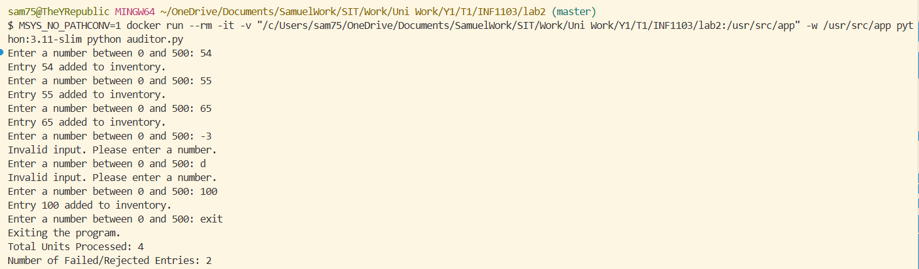
Docker Image being downloaded
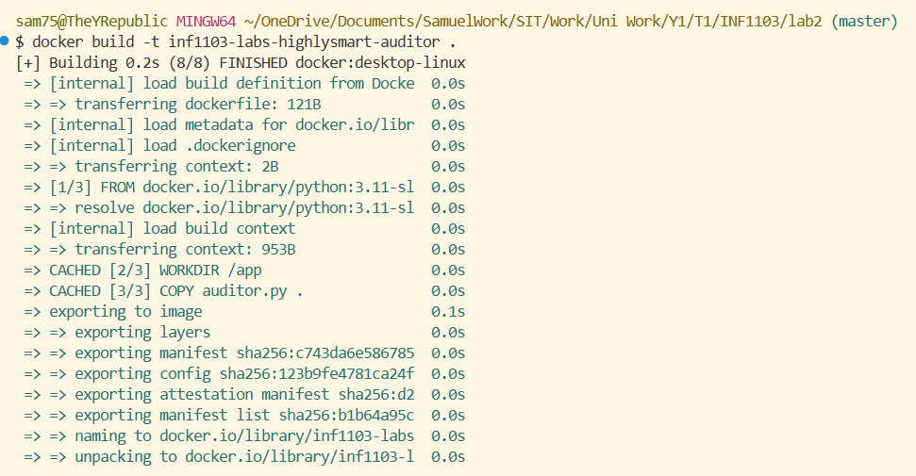

Docker image working!!
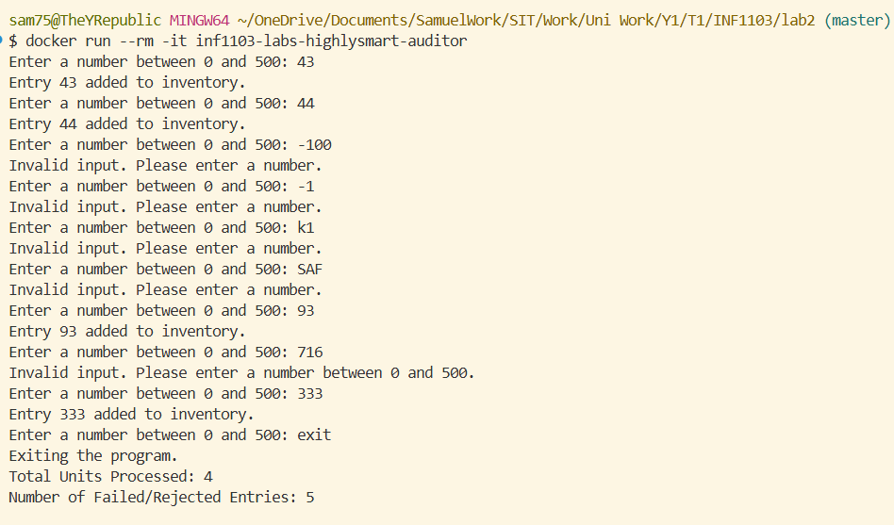
Evidence of successful Docker Image building
